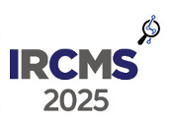
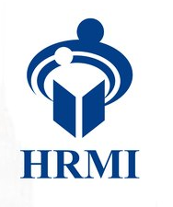


IRCMS 2025
3rd International Research Conference on Management Studies

Guidelines for Poster Presentation

Design and Layout
- All the posters should be digitally printed and, in Landscape format.
- Size of the poster should be height 2 feet and width 2 feet.
- The top of the poster should display, Title of the Paper, Name(s) of the Author(s), Affiliation(s)
- Follow a logical format so that the audience can follow and comprehend your point of view from beginning to end. A methodology, findings and conclusion should all be included.
- Maintain consistence in font choice and size. The illustrations and font size of the text should be in a size and format suitable for poster display.
- Please use complementary colors that enhance readability, and avoid using distracting patterns that may interfere with reading the poster.
- In general, the poster should be read from top to bottom and left to right (See Figure 1).

Abstract
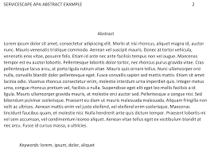
Design/Methodology
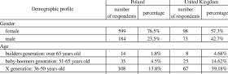
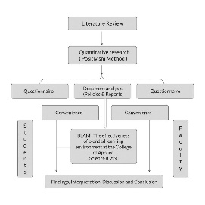
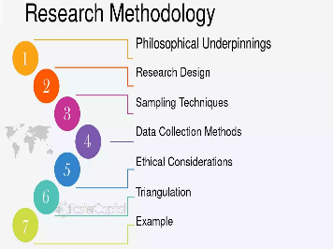
Results
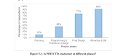
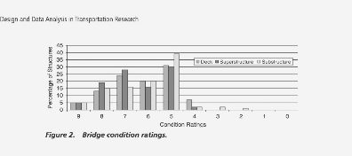
Conclusion

Sample #Sample# #Sample
RESEARCH TITE
<<<Author’s Name>>>>
<<<<Affiliation(s)>>>>

Figure 01

Setup and Presentation
- Arrive before 08.30 am (7th December 2025) to setup your poster in the assigned space (Please contact Research Cell UNISTEM for further details).
- A display board and mounting materials will be provided and organizing committee will be there to mounting your poster.
- Prepare a brief (4-5 minutes) verbal summary of your work to engage viewers.
- Be ready to answer questions and network.
- The best poster presentation winner will be announced at the end of the Research Conference.
Contact for Queries
For any clarifications and questions, please contact:

Poster Session Coordinator
Sanduni Jayawardhana – Research Cell UNISTEM
Mobile – 076 441 0345
Email – sanduni@hrmi.lk

